**Course: 405-02: Mobile Application Development – 2**

**Unit-2 : Basic Attributes and Events of Important Android Widgets(UI)**

2.1 ListView, Custom ListView

Android ListView

Android **ListView** is a view which contains the group of items and displays in a scrollable list. ListView is implemented by importing *android.widget.ListView* class. ListView is a default scrollable which does not use other scroll view.

ListView uses Adapter classes which add the content from data source (such as string array, array, database etc) to ListView. Adapter bridges data between an *AdapterViews* and other Views (ListView, ScrollView etc).

Example of ListView

Let's implement a simple listview example.

**Structure of listview project**

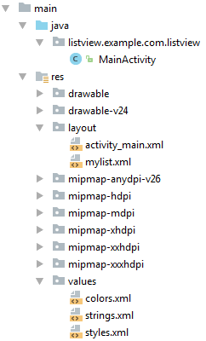

activity_main.xml

First we need to drag and drop ListView component from palette to activity_main.xml file.

***File: activity_main.xml***

**<?xml** version="1.0" encoding="utf-8"**?>**

**<android.support.constraint.ConstraintLayout** xmlns:android="http://schemas.android.com/apk/res/android"

    xmlns:app="http://schemas.android.com/apk/res-auto"

    xmlns:tools="http://schemas.android.com/tools"

    android:layout_width="match_parent"

    android:layout_height="match_parent"

    tools:context="listview.example.com.listview.MainActivity"**>**

**<ListView**

        android:id="@+id/listView"

        android:layout_width="match_parent"

        android:layout_height="fill_parent"

**/>**

**</android.support.constraint.ConstraintLayout>**

Create an additional mylist.xml file in layout folder which contains view components displayed in listview.

mylist.xml

***File: mylist.xml***

**<?xml** version="1.0" encoding="utf-8"**?>**

**<TextView** xmlns:android="http://schemas.android.com/apk/res/android"

    android:id="@+id/textView"

    android:layout_width="wrap_content"

    android:layout_height="wrap_content"

    android:text="Medium Text"

    android:textStyle="bold"

    android:textAppearance="?android:attr/textAppearanceMedium"

    android:layout_marginLeft="10dp"

    android:layout_marginTop="5dp"

    android:padding="2dp"

    android:textColor="#4d4d4d"

**/>**

Now place the list of data in strings.xml file by creating string-array.

strings.xml

***File:strings.xml***

**<resources>**

**<string** name="app_name"**>**ListView**</string>**

**<string-array** name="array_technology"**>**

**<item>**Android**</item>**

**<item>**Java**</item>**

**<item>**Php**</item>**

**<item>**Hadoop**</item>**

**<item>**Sap**</item>**

**<item>**Python**</item>**

**<item>**Ajax**</item>**

**<item>**C++**</item>**

**<item>**Ruby**</item>**

**<item>**Rails**</item>**

**<item>**.Net**</item>**

**<item>**Perl**</item>**

**</string-array>**

**</resources>**

Activity class

In java class we need to add adapter to listview using setAdapter() method of listview.

***File: MainActivity.java***

**package** listview.example.com.listview;

**import** android.support.v7.app.AppCompatActivity;

**import** android.os.Bundle;

**import** android.view.View;

**import** android.widget.AdapterView;

**import** android.widget.ArrayAdapter;

**import** android.widget.ListView;

**import** android.widget.TextView;

**import** android.widget.Toast;

**public** **class** MainActivity **extends** AppCompatActivity {

    ListView listView;

    TextView textView;

    String[] listItem;

    @Override

**protected** **void** onCreate(Bundle savedInstanceState) {

**super**.onCreate(savedInstanceState);

        setContentView(R.layout.activity_main);

        listView=(ListView)findViewById(R.id.listView);

        textView=(TextView)findViewById(R.id.textView);

        listItem = getResources().getStringArray(R.array.array_technology);

**final** ArrayAdapter<String> adapter = **new** ArrayAdapter<String>(**this**,

                android.R.layout.simple_list_item_1, android.R.id.text1, listItem);

        listView.setAdapter(adapter);

        listView.setOnItemClickListener(**new** AdapterView.OnItemClickListener() {

            @Override

**public** **void** onItemClick(AdapterView<?> adapterView, View view, **int** position, **long** l) {

                // TODO Auto-generated method stub

                String value=adapter.getItem(position);

                Toast.makeText(getApplicationContext(),value,Toast.LENGTH_SHORT).show();

            }

        });

    }

}

Output:

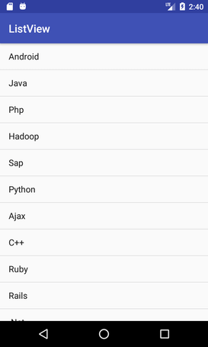 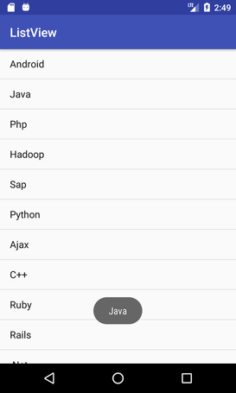

**Android Custom ListView (Adding Images, sub-title)**

After creating simple ListView, android also provides facilities to customize our ListView.

As the simple ListView, custom ListView also uses Adapter classes which added the content from data source (such as string array, array, database etc). Adapter bridges data between an AdapterViews and other Views

Example of Custom ListView

In this custom listview example, we are adding image, text with title and its sub-title.

**Structure of custom listview project**

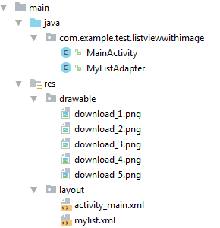

activity_main.xml

Create an activity_main.xml file in layout folder.

***File: activity_main.xml***

**<?xml** version="1.0" encoding="utf-8"**?>**

**<RelativeLayout** xmlns:android="http://schemas.android.com/apk/res/android"

    xmlns:tools="http://schemas.android.com/tools"

    android:layout_width="match_parent"

    android:layout_height="match_parent"

    android:paddingBottom="@dimen/activity_vertical_margin"

    android:paddingLeft="@dimen/activity_horizontal_margin"

    android:paddingRight="@dimen/activity_horizontal_margin"

    android:paddingTop="@dimen/activity_vertical_margin"

    tools:context="com.example.test.listviewwithimage.MainActivity"**>**

**<ListView**

        android:id="@+id/list"

        android:layout_width="match_parent"

        android:layout_height="wrap_content"

        android:layout_marginBottom="50dp"**>**

**</ListView>**

**</RelativeLayout>**

Create an additional mylist.xml file in layout folder which contains view components displayed in listview.

mylist.xml

***File: mylist.xml***

**<?xml** version="1.0" encoding="utf-8"**?>**

**<LinearLayout** xmlns:android="http://schemas.android.com/apk/res/android"

    android:layout_width="match_parent"

    android:layout_height="match_parent"

    android:orientation="horizontal" **>**

**<ImageView**

        android:id="@+id/icon"

        android:layout_width="60dp"

        android:layout_height="60dp"

        android:padding="5dp" **/>**

**<LinearLayout** android:layout_width="wrap_content"

        android:layout_height="wrap_content"

        android:orientation="vertical"**>**

**<TextView**

        android:id="@+id/title"

        android:layout_width="wrap_content"

        android:layout_height="wrap_content"

        android:text="Medium Text"

        android:textStyle="bold"

        android:textAppearance="?android:attr/textAppearanceMedium"

        android:layout_marginLeft="10dp"

        android:layout_marginTop="5dp"

        android:padding="2dp"

        android:textColor="#4d4d4d" **/>**

**<TextView**

        android:id="@+id/subtitle"

        android:layout_width="wrap_content"

        android:layout_height="wrap_content"

        android:text="TextView"

        android:layout_marginLeft="10dp"**/>**

**</LinearLayout>**

**</LinearLayout>**

Place the all required images in drawable folder.

Activity class

***File: MainActivity.java***

**package** com.example.test.listviewwithimage;

**import** android.support.v7.app.AppCompatActivity;

**import** android.os.Bundle;

**import** android.view.View;

**import** android.widget.AdapterView;

**import** android.widget.ListView;

**import** android.widget.Toast;

**public** **class** MainActivity **extends** AppCompatActivity {

    ListView list;

    String[] maintitle ={

            "Title 1","Title 2",

            "Title 3","Title 4",

            "Title 5",

    };

    String[] subtitle ={

            "Sub Title 1","Sub Title 2",

            "Sub Title 3","Sub Title 4",

            "Sub Title 5",

    };

    Integer[] imgid={

            R.drawable.download_1,R.drawable.download_2,

            R.drawable.download_3,R.drawable.download_4,

            R.drawable.download_5,

    };

    @Override

**protected** **void** onCreate(Bundle savedInstanceState) {

**super**.onCreate(savedInstanceState);

        setContentView(R.layout.activity_main);

        MyListAdapter adapter=**new** MyListAdapter(**this**, maintitle, subtitle,imgid);

        list=(ListView)findViewById(R.id.list);

        list.setAdapter(adapter);

        list.setOnItemClickListener(**new** AdapterView.OnItemClickListener() {

            @Override

**public** **void** onItemClick(AdapterView<?> parent, View view,**int** position, **long** id) {

                // TODO Auto-generated method stub

**if**(position == 0) {

                    //code specific to first list item

                    Toast.makeText(getApplicationContext(),"Place Your First Option Code",Toast.LENGTH_SHORT).show();

                }

**else** **if**(position == 1) {

                    //code specific to 2nd list item

                    Toast.makeText(getApplicationContext(),"Place Your Second Option Code",Toast.LENGTH_SHORT).show();

                }

**else** **if**(position == 2) {

                    Toast.makeText(getApplicationContext(),"Place Your Third Option Code",Toast.LENGTH_SHORT).show();

                }

**else** **if**(position == 3) {

                    Toast.makeText(getApplicationContext(),"Place Your Forth Option Code",Toast.LENGTH_SHORT).show();

                }

**else** **if**(position == 4) {

                    Toast.makeText(getApplicationContext(),"Place Your Fifth Option Code",Toast.LENGTH_SHORT).show();

                }

            }

        });

    }

}

Customize Our ListView

Create another java class MyListView.java which extends ArrayAdapter class. This class customizes our listview.

***MyListView.java***

**package** com.example.test.listviewwithimage;

**import** android.app.Activity;

**import** android.view.LayoutInflater;

**import** android.view.View;

**import** android.view.ViewGroup;

**import** android.widget.ArrayAdapter;

**import** android.widget.ImageView;

**import** android.widget.TextView;

**public** **class** MyListAdapter **extends** ArrayAdapter<String> {

**private** **final** Activity context;

**private** **final** String[] maintitle;

**private** **final** String[] subtitle;

**private** **final** Integer[] imgid;

**public** MyListAdapter(Activity context, String[] maintitle,String[] subtitle, Integer[] imgid) {

**super**(context, R.layout.mylist, maintitle);

        // TODO Auto-generated constructor stub

**this**.context=context;

**this**.maintitle=maintitle;

**this**.subtitle=subtitle;

**this**.imgid=imgid;

    }

**public** View getView(**int** position,View view,ViewGroup parent) {

        LayoutInflater inflater=context.getLayoutInflater();

        View rowView=inflater.inflate(R.layout.mylist, **null**,**true**);

        TextView titleText = (TextView) rowView.findViewById(R.id.title);

        ImageView imageView = (ImageView) rowView.findViewById(R.id.icon);

        TextView subtitleText = (TextView) rowView.findViewById(R.id.subtitle);

        titleText.setText(maintitle[position]);

        imageView.setImageResource(imgid[position]);

        subtitleText.setText(subtitle[position]);

**return** rowView;

    };

}

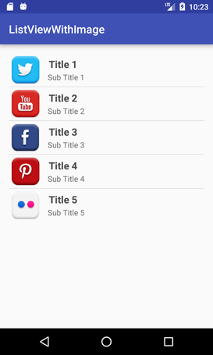 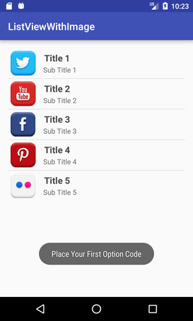

2.2 DatePicker, TimePicker, ProgressBar

**Android DatePicker** 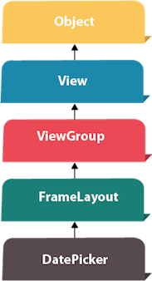

Android DatePicker is a widget to select date. It allows you to select date by day, month and year. Like DatePicker, android also provides TimePicker to select time.

The android.widget.DatePicker is the subclass of FrameLayout class.

Android DatePicker Example

Let's see the simple example of datepicker widget in android.

activity_main.xml

*File: activity_main.xml*

**<?xml** version="1.0" encoding="utf-8"**?>**

**<RelativeLayout** xmlns:android="http://schemas.android.com/apk/res/android"

    xmlns:app="http://schemas.android.com/apk/res-auto"

    xmlns:tools="http://schemas.android.com/tools"

    android:layout_width="match_parent"

    android:layout_height="match_parent"

    tools:context="example.javatpoint.com.datepicker.MainActivity"**>**

**<TextView**

        android:id="@+id/textView1"

        android:layout_width="wrap_content"

        android:layout_height="wrap_content"

        android:layout_above="@+id/button1"

        android:layout_alignParentLeft="true"

        android:layout_alignParentStart="true"

        android:layout_marginBottom="102dp"

        android:layout_marginLeft="30dp"

        android:layout_marginStart="30dp"

        android:text="" **/>**

**<Button**

        android:id="@+id/button1"

        android:layout_width="wrap_content"

        android:layout_height="wrap_content"

        android:layout_alignParentBottom="true"

        android:layout_centerHorizontal="true"

        android:layout_marginBottom="20dp"

        android:text="Change Date" **/>**

**<DatePicker**

        android:id="@+id/datePicker"

        android:layout_width="wrap_content"

        android:layout_height="wrap_content"

        android:layout_above="@+id/textView1"

        android:layout_centerHorizontal="true"

        android:layout_marginBottom="36dp" **/>**

**</RelativeLayout>**

Activity class

*File: MainActivity.java*

**package** example.javatpoint.com.datepicker;

**import** android.support.v7.app.AppCompatActivity;

**import** android.os.Bundle;

**import** android.view.View;

**import** android.widget.Button;

**import** android.widget.DatePicker;

**import** android.widget.TextView;

**public** **class** MainActivity **extends** AppCompatActivity {

    DatePicker picker;

    Button displayDate;

    TextView textview1;

    @Override

**protected** **void** onCreate(Bundle savedInstanceState) {

**super**.onCreate(savedInstanceState);

        setContentView(R.layout.activity_main);

        textview1=(TextView)findViewById(R.id.textView1);

        picker=(DatePicker)findViewById(R.id.datePicker);

        displayDate=(Button)findViewById(R.id.button1);

        textview1.setText("Current Date: "+getCurrentDate());

        displayDate.setOnClickListener(**new** View.OnClickListener(){

            @Override

**public** **void** onClick(View view) {

                textview1.setText("Change Date: "+getCurrentDate());

            }

        });

    }

**public** String getCurrentDate(){

        StringBuilder builder=**new** StringBuilder();;

        builder.append((picker.getMonth() + 1)+"/");//month is 0 based

        builder.append(picker.getDayOfMonth()+"/");

        builder.append(picker.getYear());

**return** builder.toString();

    }

}

Output:

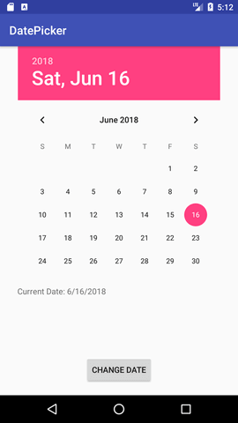 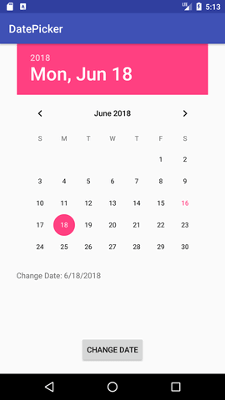

**Android TimePicker**

**Android TimePicker** widget is used to select date. It allows you to select time by hour and minute. You cannot select time by seconds.

The android.widget.TimePicker is the subclass of FrameLayout class.

Android TimePicker Example

Let's see a simple example of android time picker.

activity_main.xml

*File: activity_main.xml*

**<?xml** version="1.0" encoding="utf-8"**?>**

**<RelativeLayout** xmlns:android="http://schemas.android.com/apk/res/android"

    xmlns:app="http://schemas.android.com/apk/res-auto"

    xmlns:tools="http://schemas.android.com/tools"

    android:layout_width="match_parent"

    android:layout_height="match_parent"

    tools:context="example.javatpoint.com.timepicker.MainActivity"**>**

**<TextView**

        android:id="@+id/textView1"

        android:layout_width="wrap_content"

        android:layout_height="wrap_content"

        android:layout_above="@+id/button1"

        android:layout_alignParentLeft="true"

        android:layout_alignParentStart="true"

        android:layout_marginBottom="102dp"

        android:layout_marginLeft="30dp"

        android:layout_marginStart="30dp"

        android:text="" **/>**

**<Button**

        android:id="@+id/button1"

        android:layout_width="wrap_content"

        android:layout_height="wrap_content"

        android:layout_alignParentBottom="true"

        android:layout_centerHorizontal="true"

        android:layout_marginBottom="20dp"

        android:text="Change Time" **/>**

**<TimePicker**

        android:id="@+id/timePicker"

        android:layout_width="wrap_content"

        android:layout_height="wrap_content"

        android:layout_above="@+id/textView1"

        android:layout_centerHorizontal="true"

        android:layout_marginBottom="36dp" **/>**

**</RelativeLayout>**

Activity class

*File: MainActivity.java*

**package** example.javatpoint.com.timepicker;

**import** android.support.v7.app.AppCompatActivity;

**import** android.os.Bundle;

**import** android.view.View;

**import** android.widget.Button;

**import** android.widget.TextView;

**import** android.widget.TimePicker;

**public** **class** MainActivity **extends** AppCompatActivity {

    TextView textview1;

    TimePicker timepicker;

    Button changetime;

    @Override

**protected** **void** onCreate(Bundle savedInstanceState) {

**super**.onCreate(savedInstanceState);

        setContentView(R.layout.activity_main);

        textview1=(TextView)findViewById(R.id.textView1);

        timepicker=(TimePicker)findViewById(R.id.timePicker);

        //Uncomment the below line of code for 24 hour view

        timepicker.setIs24HourView(**true**);

        changetime=(Button)findViewById(R.id.button1);

        textview1.setText(getCurrentTime());

        changetime.setOnClickListener(**new** View.OnClickListener(){

            @Override

**public** **void** onClick(View view) {

                textview1.setText(getCurrentTime());

            }

        });

    }

**public** String getCurrentTime(){

        String currentTime="Current Time: "+timepicker.getCurrentHour()+":"+timepicker.getCurrentMinute();

**return** currentTime;

    }

}

Output:

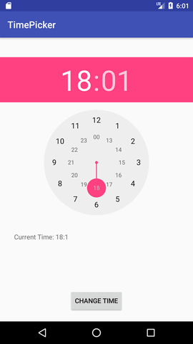 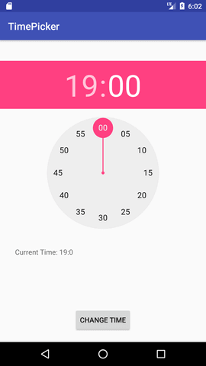

**Android Analog clock and Digital clock**

The **android.widget.AnalogClock** and **android.widget.DigitalClock** classes provides the functionality to display analog and digital clocks.

Android analog and digital clocks are used to show time in android application.

Android AnalogClock is the subclass of View class.

Android DigitalClock is the subclass of TextView class. Since Android API level 17, it is *deprecated*. You are recommended to use **TextClock** Instead.

The AnalogClock was deprecated in API level 23. This widget is no longer supported. Instead if you want to use AnalogClock in your application you need to hard code. It does not appear in API level 27 to drag from palette.

Note: Analog and Digital clocks cannot be used to change the time of the device. To do so, you need to use DatePicker and TimePicker.

In android, you need to drag analog and digital clocks from the pallet to display analog and digital clocks.

activity_main.xml

Now, drag the analog and digital clocks, now the xml file will look like this.

*File: activity_main.xml*

**<?xml** version="1.0" encoding="utf-8"**?>**

**<android.support.constraint.ConstraintLayout** xmlns:android="http://schemas.android.com/apk/res/android"

    xmlns:app="http://schemas.android.com/apk/res-auto"

    xmlns:tools="http://schemas.android.com/tools"

    android:layout_width="match_parent"

    android:layout_height="match_parent"

    tools:context="example.javatpoint.com.analogdigital.MainActivity"**>**

**<AnalogClock**

        android:id="@+id/analogClock1"

        android:layout_width="wrap_content"

        android:layout_height="wrap_content"

        android:layout_alignParentTop="true"

        android:layout_centerHorizontal="true"

        android:layout_marginLeft="136dp"

        android:layout_marginTop="296dp"

        app:layout_constraintStart_toStartOf="parent"

        app:layout_constraintTop_toTopOf="parent" **/>**

**<DigitalClock**

        android:id="@+id/digitalClock1"

        android:layout_width="wrap_content"

        android:layout_height="wrap_content"

        android:layout_below="@+id/analogClock1"

        android:layout_centerHorizontal="true"

        android:layout_marginLeft="176dp"

        android:layout_marginTop="84dp"

        android:text="DigitalClock"

        app:layout_constraintStart_toStartOf="parent"

        app:layout_constraintTop_toTopOf="parent" **/>**

**</android.support.constraint.ConstraintLayout>**

Activity class

We have not write any code here.

*File: MainActivity.java*

**package** example.javatpoint.com.analogdigital;

**import** android.support.v7.app.AppCompatActivity;

**import** android.os.Bundle;

**public** **class** MainActivity **extends** AppCompatActivity {

    @Override

**protected** **void** onCreate(Bundle savedInstanceState) {

**super**.onCreate(savedInstanceState);

        setContentView(R.layout.activity_main);

    }

}

Output:

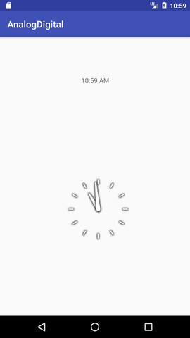

**Android ProgressBar**

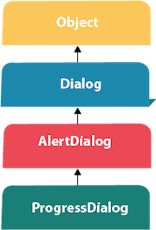We can display the **android progress bar** dialog box to display the status of work being done e.g. downloading file, analyzing status of work etc.

In this example, we are displaying the progress dialog for dummy file download operation.

Here we are using **android.app.ProgressDialog** class to show the progress bar. Android ProgressDialog is the subclass of AlertDialog class.

The **ProgressDialog** class provides methods to work on progress bar like setProgress(), setMessage(), setProgressStyle(), setMax(), show() etc. The progress range of Progress Dialog is 0 to 10000.

Let's see a simple example to display progress bar in android.

ProgressDialog progressBar = **new** ProgressDialog(**this**);

progressBar.setCancelable(**true**);//you can cancel it by pressing back button

progressBar.setMessage("File downloading ...");

progressBar.setProgressStyle(ProgressDialog.STYLE_HORIZONTAL);

progressBar.setProgress(0);//initially progress is 0

progressBar.setMax(100);//sets the maximum value 100

progressBar.show();//displays the progress bar

Android Progress Bar Example by ProgressDialog

Let's see a simple example to create progress bar using ProgressDialog class.

activity_main.xml

Drag one button from the pallete, now the activity_main.xml file will look like this:

*File: activity_main.xml*

**<RelativeLayout** xmlns:androclass="http://schemas.android.com/apk/res/android"

    xmlns:tools="http://schemas.android.com/tools"

    android:layout_width="match_parent"

    android:layout_height="match_parent"

    tools:context=".MainActivity" **>**

**<Button**

        android:id="@+id/button1"

        android:layout_width="wrap_content"

        android:layout_height="wrap_content"

        android:layout_alignParentTop="true"

        android:layout_centerHorizontal="true"

        android:layout_marginTop="116dp"

        android:text="download file" **/>**

**</RelativeLayout>**

Activity class

Let's write the code to display the progress bar dialog box.

*File: MainActivity.java*

**package** example.javatpoint.com.progressbar;

**import** android.app.ProgressDialog;

**import** android.os.Handler;

**import** android.support.v7.app.AppCompatActivity;

**import** android.os.Bundle;

**import** android.view.View;

**import** android.widget.Button;

**public** **class** MainActivity **extends** AppCompatActivity {

    Button btnStartProgress;

    ProgressDialog progressBar;

**private** **int** progressBarStatus = 0;

**private** Handler progressBarHandler = **new** Handler();

**private** **long** fileSize = 0;

    @Override

**protected** **void** onCreate(Bundle savedInstanceState) {

**super**.onCreate(savedInstanceState);

        setContentView(R.layout.activity_main);

        addListenerOnButtonClick();

    }

**public** **void** addListenerOnButtonClick() {

        btnStartProgress = findViewById(R.id.button);

        btnStartProgress.setOnClickListener(**new** View.OnClickListener(){

            @Override

**public** **void** onClick(View v) {

                // creating progress bar dialog

                progressBar = **new** ProgressDialog(v.getContext());

                progressBar.setCancelable(**true**);

                progressBar.setMessage("File downloading ...");

                progressBar.setProgressStyle(ProgressDialog.STYLE_HORIZONTAL);

                progressBar.setProgress(0);

                progressBar.setMax(100);

                progressBar.show();

                //reset progress bar and filesize status

                progressBarStatus = 0;

                fileSize = 0;

**new** Thread(**new** Runnable() {

**public** **void** run() {

**while** (progressBarStatus < 100) {

                            // performing operation

                            progressBarStatus = doOperation();

**try** {

                                Thread.sleep(1000);

                            } **catch** (InterruptedException e) {

                                e.printStackTrace();

                            }

                            // Updating the progress bar

                            progressBarHandler.post(**new** Runnable() {

**public** **void** run() {

                                    progressBar.setProgress(progressBarStatus);

                                }

                            });

                        }

                        // performing operation if file is downloaded,

**if** (progressBarStatus >= 100) {

                            // sleeping for 1 second after operation completed

**try** {

                                Thread.sleep(1000);

                            } **catch** (InterruptedException e) {

                                e.printStackTrace();

                            }

                            // close the progress bar dialog

                            progressBar.dismiss();

                        }

                    }

                }).start();

            }//end of onClick method

        });

    }

    // checking how much file is downloaded and updating the filesize

**public** **int** doOperation() {

        //The range of ProgressDialog starts from 0 to 10000

**while** (fileSize <= 10000) {

            fileSize++;

**if** (fileSize == 1000) {

**return** 10;

            } **else** **if** (fileSize == 2000) {

**return** 20;

            } **else** **if** (fileSize == 3000) {

**return** 30;

            } **else** **if** (fileSize == 4000) {

**return** 40; // you can add more else if

            }

         /* else {

                return 100;

            }*/

        }//end of while

**return** 100;

    }//end of doOperation

}

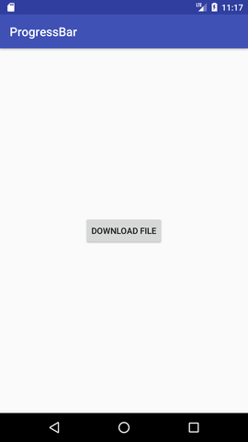 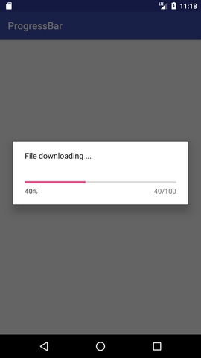

2.3 Horizontal and Vertical ScrollView

**Android ScrollView (Vertical)**

The **android.widget.ScrollView** class provides the functionality of scroll view. ScrollView is used to scroll the child elements of palette inside ScrollView. Android supports vertical scroll view as default scroll view. Vertical ScrollView scrolls elements vertically.

Android uses *HorizontalScrollView* for horizontal ScrollView.

Let's implement simple example of vertical ScrollView.

activity_main.xml

Now, drag ScrollView from palette to activity_main.xml file and place some palette element inside it.

**File: activity_main.xml**

**<?xml** version="1.0" encoding="utf-8"**?>**

**<RelativeLayout** xmlns:android="http://schemas.android.com/apk/res/android"

    xmlns:tools="http://schemas.android.com/tools"

    android:layout_width="match_parent"

    android:layout_height="match_parent"

    android:paddingBottom="@dimen/activity_vertical_margin"

    android:paddingLeft="@dimen/activity_horizontal_margin"

    android:paddingRight="@dimen/activity_horizontal_margin"

    android:paddingTop="@dimen/activity_vertical_margin"

    tools:context="com.example.test.scrollviews.MainActivity"**>**

**<TextView**

        android:layout_width="wrap_content"

        android:layout_height="wrap_content"

        android:textAppearance="?android:attr/textAppearanceMedium"

        android:text="Vertical ScrollView example"

        android:id="@+id/textView"

        android:layout_gravity="center_horizontal"

        android:layout_centerHorizontal="true"

        android:layout_alignParentTop="true" **/>**

**<ScrollView** android:layout_marginTop="30dp"

        android:layout_width="fill_parent"

        android:layout_height="wrap_content"

        android:id="@+id/scrollView"**>**

**<LinearLayout**

            android:layout_width="fill_parent"

            android:layout_height="fill_parent"

            android:orientation="vertical" **>**

**<Button**

                android:layout_width="fill_parent"

                android:layout_height="wrap_content"

                android:text="Button 1" **/>**

**<Button**

                android:layout_width="fill_parent"

                android:layout_height="wrap_content"

                android:text="Button 2" **/>**

**<Button**

                android:layout_width="fill_parent"

                android:layout_height="wrap_content"

                android:text="Button 3" **/>**

**<Button**

                android:layout_width="fill_parent"

                android:layout_height="wrap_content"

                android:text="Button 4" **/>**

**<Button**

                android:layout_width="fill_parent"

                android:layout_height="wrap_content"

                android:text="Button 5" **/>**

**<Button**

                android:layout_width="fill_parent"

                android:layout_height="wrap_content"

                android:text="Button 6" **/>**

**<Button**

                android:layout_width="fill_parent"

                android:layout_height="wrap_content"

                android:text="Button 7" **/>**

**<Button**

                android:layout_width="fill_parent"

                android:layout_height="wrap_content"

                android:text="Button 8" **/>**

**<Button**

                android:layout_width="fill_parent"

                android:layout_height="wrap_content"

                android:text="Button 9" **/>**

**<Button**

                android:layout_width="fill_parent"

                android:layout_height="wrap_content"

                android:text="Button 10" **/>**

**<Button**

                android:layout_width="fill_parent"

                android:layout_height="wrap_content"

                android:text="Button 11" **/>**

**<Button**

                android:layout_width="fill_parent"

                android:layout_height="wrap_content"

                android:text="Button 12" **/>**

**<Button**

                android:layout_width="fill_parent"

                android:layout_height="wrap_content"

                android:text="Button 13" **/>**

**<Button**

                android:layout_width="fill_parent"

                android:layout_height="wrap_content"

                android:text="Button 14" **/>**

**<Button**

                android:layout_width="fill_parent"

                android:layout_height="wrap_content"

                android:text="Button 15" **/>**

**<Button**

                android:layout_width="fill_parent"

                android:layout_height="wrap_content"

                android:text="Button 16" **/>**

**<Button**

                android:layout_width="fill_parent"

                android:layout_height="wrap_content"

                android:text="Button 17" **/>**

**<Button**

                android:layout_width="fill_parent"

                android:layout_height="wrap_content"

                android:text="Button 18" **/>**

**<Button**

                android:layout_width="fill_parent"

                android:layout_height="wrap_content"

                android:text="Button 19" **/>**

**<Button**

                android:layout_width="fill_parent"

                android:layout_height="wrap_content"

                android:text="Button 20" **/>**

**</LinearLayout>**

**</ScrollView>**

**</RelativeLayout>**

Activity class

In activity class, we have not changed any code.

**File: MainActivity.java**

**package** com.example.test.scrollviews;

**import** android.support.v7.app.AppCompatActivity;

**import** android.os.Bundle;

**public** **class** MainActivity **extends** AppCompatActivity {

    @Override

**protected** **void** onCreate(Bundle savedInstanceState) {

**super**.onCreate(savedInstanceState);

        setContentView(R.layout.activity_main);

    }

}

Output:

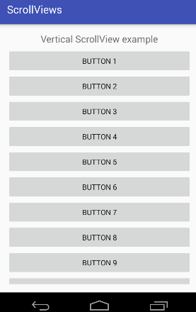 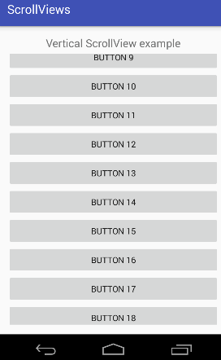

**Android HorizontalScrollView**

A **HorizontalScrollView** is a *FrameLayout*. The **android.widget.HorizontalScrollView** class provides the functionality of horizontal scroll view. HorizontalScrollView is used to scroll the child elements or views in a horizontal direction. HorizontalScrollView only supports horizontal scrolling.

For vertical scroll, android uses *ScrollView*.

Let's implement simple example of *HorizontalScrollView*.

activity_main.xml

Now, drag HorizontalScrollView from palette to activity_main.xml file and place some views or elements inside it.

**<?xml** version="1.0" encoding="utf-8"**?>**

**<RelativeLayout** xmlns:android="http://schemas.android.com/apk/res/android"

    android:layout_width="fill_parent"

    android:layout_height="fill_parent"**>**

**<TextView**

        android:layout_width="wrap_content"

        android:layout_height="wrap_content"

        android:textAppearance="?android:attr/textAppearanceSmall"

        android:text="Horizontal ScrollView Example"

        android:id="@+id/textView"

        android:layout_alignParentTop="true"

        android:layout_centerHorizontal="true" **/>**

**<LinearLayout**

        android:layout_width="match_parent"

        android:layout_height="match_parent"

        android:layout_marginTop="25dp"**>**

**<HorizontalScrollView**

            android:layout_width="match_parent"

            android:layout_height="60dp"

            android:id="@+id/horizontalScrollView"**>**

**<LinearLayout**

                android:layout_width="wrap_content"

                android:layout_height="wrap_content"

                android:orientation="horizontal"**>**

**<Button**

                    android:layout_width="wrap_content"

                    android:layout_height="wrap_content"

                    android:text="New Button1"

                    android:id="@+id/button1" **/>**

**<Button**

                    android:layout_width="wrap_content"

                    android:layout_height="wrap_content"

                    android:text="New Button2"

                    android:id="@+id/button2" **/>**

**<Button**

                    android:layout_width="wrap_content"

                    android:layout_height="wrap_content"

                    android:text="New Button3"

                    android:id="@+id/button3" **/>**

**<Button**

                    android:layout_width="wrap_content"

                    android:layout_height="wrap_content"

                    android:text="New Button4"

                    android:id="@+id/button4" **/>**

**<Button**

                    android:layout_width="wrap_content"

                    android:layout_height="wrap_content"

                    android:text="New Button5"

                    android:id="@+id/button5" **/>**

**<Button**

                    android:layout_width="wrap_content"

                    android:layout_height="wrap_content"

                    android:text="New Button6"

                    android:id="@+id/button6" **/>**

**<Button**

                    android:layout_width="wrap_content"

                    android:layout_height="wrap_content"

                    android:text="New Button7"

                    android:id="@+id/button7" **/>**

**<Button**

                    android:layout_width="wrap_content"

                    android:layout_height="wrap_content"

                    android:text="New Button8"

                    android:id="@+id/button8"**/>**

**</LinearLayout>**

**</HorizontalScrollView>**

**</LinearLayout>**

**</RelativeLayout>**

Activity class

This is auto generated code, we have not written any code here.

**File: MainActivity.java**

**package** com.example.test.horizantalscrollview;

**import** android.support.v7.app.AppCompatActivity;

**import** android.os.Bundle;

**public** **class** MainActivity **extends** AppCompatActivity {

    @Override

**protected** **void** onCreate(Bundle savedInstanceState) {

**super**.onCreate(savedInstanceState);

        setContentView(R.layout.activity_main);

    }

}

Output:

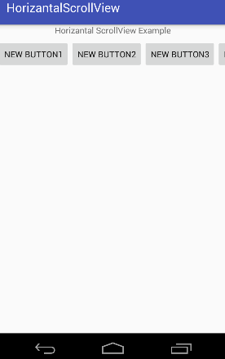 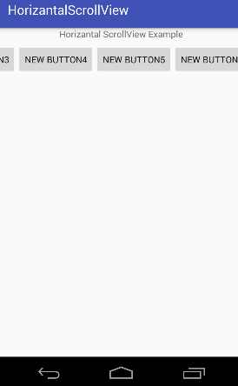

2.4 AutoCompleteTextView, TextWatcher to EditText

**Android AutoCompleteTextView**

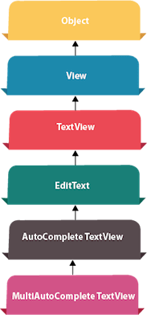**Android AutoCompleteTextView** completes the word based on the reserved words, so no need to write all the characters of the word.

Android AutoCompleteTextView is a editable text field, it displays a list of suggestions in a drop down menu from which user can select only one suggestion or value.

Android AutoCompleteTextView is the subclass of EditText class. The MultiAutoCompleteTextView is the subclass of AutoCompleteTextView class.

Android AutoCompleteTextView Example

In this example, we are displaying the programming languages in the autocompletetextview. All the programming languages are stored in string array. We are using the **ArrayAdapter** class to display the array content.

Let's see the simple example of autocompletetextview in android.

activity_main.xml

Drag the AutoCompleteTextView and TextView from the pallete, now the activity_main.xml file will like this:

*File: activity_main.xml*

**<?xml** version="1.0" encoding="utf-8"**?>**

**<android.support.constraint.ConstraintLayout** xmlns:android="http://schemas.android.com/apk/res/android"

    xmlns:app="http://schemas.android.com/apk/res-auto"

    xmlns:tools="http://schemas.android.com/tools"

    android:layout_width="match_parent"

    android:layout_height="match_parent"

    tools:context="example.javatpoint.com.autocompletetextview.MainActivity"**>**

**<TextView**

        android:layout_width="wrap_content"

        android:layout_height="wrap_content"

        android:text="What is your favourite programming language?"

        app:layout_constraintBottom_toBottomOf="parent"

        app:layout_constraintLeft_toLeftOf="parent"

        app:layout_constraintRight_toRightOf="parent"

        app:layout_constraintTop_toTopOf="parent"

        app:layout_constraintVertical_bias="0.032" **/>**

**<AutoCompleteTextView**

        android:id="@+id/autoCompleteTextView"

        android:layout_width="200dp"

        android:layout_height="wrap_content"

        android:layout_marginLeft="92dp"

        android:layout_marginTop="144dp"

        android:text=""

        app:layout_constraintStart_toStartOf="parent"

        app:layout_constraintTop_toTopOf="parent" **/>**

**</android.support.constraint.ConstraintLayout>**

Activity class

Let's write the code of AutoCompleteTextView.

*File: MainActivity.java*

1. **package** example.javatpoint.com.autocompletetextview;

**import** android.graphics.Color;

**import** android.support.v7.app.AppCompatActivity;

**import** android.os.Bundle;

**import** android.widget.ArrayAdapter;

**import** android.widget.AutoCompleteTextView;

**public** **class** MainActivity **extends** AppCompatActivity {

    String[] language ={"C","C++","Java",".NET","iPhone","Android","ASP.NET","PHP"};

    @Override

**protected** **void** onCreate(Bundle savedInstanceState) {

**super**.onCreate(savedInstanceState);

        setContentView(R.layout.activity_main);

        //Creating the instance of ArrayAdapter containing list of language names

        ArrayAdapter<String> adapter = **new** ArrayAdapter<String>

                (**this**,android.R.layout.select_dialog_item,language);

        //Getting the instance of AutoCompleteTextView

        AutoCompleteTextView actv =  (AutoCompleteTextView)findViewById(R.id.autoCompleteTextView);

        actv.setThreshold(1);//will start working from first character

        actv.setAdapter(adapter);//setting the adapter data into the AutoCompleteTextView

        actv.setTextColor(Color.RED);

    }

}

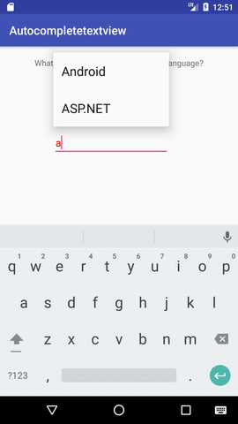 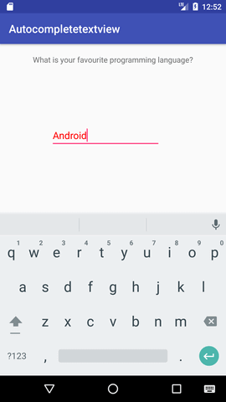

**Android EditText with TextWatcher (Searching data from ListView)**

Android **EditText** is a subclass of *TextView*. EditText is used for entering and modifying text. While using EditText width, we must specify its input type in *inputType* property of EditText which configures the keyboard according to input.

EditText uses **TextWatcher** interface to watch change made over EditText. For doing this, EditText calls the *addTextChangedListener()* method.

Methods of TextWatcher

1. **beforeTextChanged(CharSequence arg0, int arg1, int arg2, int arg3):** It is executed before making any change over EditText.
2. **onTextChanged(CharSequence cs, int arg1, int arg2, int arg3):** It is executed while making any change over EditText.
3. **afterTextChanged(Editable arg0):** It is executed after change made over EditText.

Example of EditText with TextWatcher()

In this example, we will implement EditText with TextWatcher to search data from ListView.

activity_main.xml

Create an activity_main.xml file in layout folder containing EditText and ListView.

***File: activity_main.xml***

**<?xml** version="1.0" encoding="utf-8"**?>**

**<RelativeLayout** xmlns:android="http://schemas.android.com/apk/res/android"

    xmlns:tools="http://schemas.android.com/tools"

    android:layout_width="match_parent"

    android:layout_height="match_parent"

    android:paddingBottom="@dimen/activity_vertical_margin"

    android:paddingLeft="@dimen/activity_horizontal_margin"

    android:paddingRight="@dimen/activity_horizontal_margin"

    android:paddingTop="@dimen/activity_vertical_margin"

    tools:context="com.example.test.searchfromlistview.MainActivity"**>**

**<EditText**

        android:layout_width="wrap_content"

        android:layout_height="wrap_content"

        android:id="@+id/editText"

        android:inputType="text"

        android:layout_alignParentTop="true"

        android:layout_alignParentLeft="true"

        android:layout_alignParentStart="true"

        android:layout_alignParentRight="true"

        android:layout_alignParentEnd="true" **/>**

**<ListView**

        android:layout_width="wrap_content"

        android:layout_height="wrap_content"

        android:id="@+id/listView"

        android:layout_below="@+id/editText"

        android:layout_alignParentLeft="true"

        android:layout_alignParentStart="true" **/>**

**</RelativeLayout>**

Create another file list_item.xml in layout folder which contains data of ListView.

list_item.xm

***File: list_item.xml***

**<?xml** version="1.0" encoding="utf-8"**?>**

**<LinearLayout**

    xmlns:android="http://schemas.android.com/apk/res/android"

    android:orientation="vertical"

    android:layout_width="match_parent"

    android:layout_height="match_parent"**>**

**<TextView** android:id="@+id/product_name"

    android:layout_width="fill_parent"

    android:layout_height="wrap_content"

    android:padding="10dip"

    android:textSize="16dip"

    android:textStyle="bold"**/>**

**</LinearLayout>**

Activity class

***Activity class***

**package** com.example.test.searchfromlistview;

**import** android.os.Bundle;

**import** android.text.Editable;

**import** android.text.TextWatcher;

**import** android.widget.ArrayAdapter;

**import** android.widget.EditText;

**import** android.widget.ListView;

**import** android.support.v7.app.AppCompatActivity;

**import** android.widget.Toast;

**public** **class** MainActivity **extends** AppCompatActivity {

**private** ListView lv;

**private** EditText editText;

**private** ArrayAdapter<String> adapter;

**private** String products[] = {"Apple", "Banana","Pinapple", "Orange", "Papaya", "Melon",

            "Grapes", "Water Melon","Lychee", "Guava", "Mango", "Kivi"};

    @Override

**protected** **void** onCreate(Bundle savedInstanceState) {

**super**.onCreate(savedInstanceState);

        setContentView(R.layout.activity_main);

        lv = (ListView) findViewById(R.id.listView);

        editText = (EditText) findViewById(R.id.editText);

        adapter = **new** ArrayAdapter<String>(**this**, R.layout.list_item, R.id.product_name, products);

        lv.setAdapter(adapter);

        editText.addTextChangedListener(**new** TextWatcher() {

            @Override

**public** **void** onTextChanged(CharSequence cs, **int** arg1, **int** arg2, **int** arg3) {

                adapter.getFilter().filter(cs);

            }

            @Override

**public** **void** beforeTextChanged(CharSequence arg0, **int** arg1, **int** arg2, **int** arg3) {

                Toast.makeText(getApplicationContext(),"before text change",Toast.LENGTH_LONG).show();

            }

            @Override

**public** **void** afterTextChanged(Editable arg0) {

                Toast.makeText(getApplicationContext(),"after text change",Toast.LENGTH_LONG).show();

            }

        });

    }

}

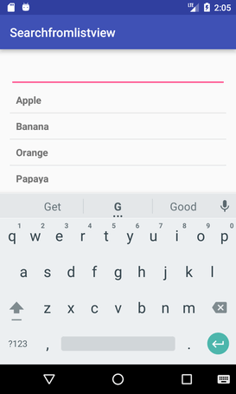 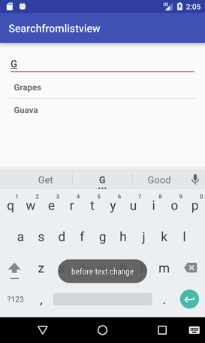

2.5 ImageSlider, ImageSwitcher, SearchView

**Android Image Slider**

Android *image slider* slides one entire screen to another screen. Image slider is created by **ViewPager** which is provided by support library. To implement image slider, you need to inherit ViewPager class which extends PagerAdapter.

Example of Image Slider

Let's see an example of android image slider.

activity_main.xml

In activity_main.xml file, we have wrapped ViewPager inside RelativeLayout.

***File: activity_main.xml***

**<?xml** version="1.0" encoding="utf-8"**?>**

**<RelativeLayout** xmlns:android="http://schemas.android.com/apk/res/android"

    xmlns:tools="http://schemas.android.com/tools"

    android:layout_width="fill_parent"

    android:layout_height="fill_parent"

    android:paddingBottom="@dimen/activity_vertical_margin"

    android:paddingLeft="@dimen/activity_horizontal_margin"

    android:paddingRight="@dimen/activity_horizontal_margin"

    android:paddingTop="@dimen/activity_vertical_margin"

    tools:context="com.example.test.imageslider.MainActivity"**>**

**<android.support.v4.view.ViewPager**

        android:id="@+id/viewPage"

        android:layout_width="fill_parent"

        android:layout_height="fill_parent" **/>**

**</RelativeLayout>**

Activity class

***File: MainActivity.java***

**package** com.example.test.imageslider;

**import** android.support.v4.view.ViewPager;

**import** android.support.v7.app.AppCompatActivity;

**import** android.os.Bundle;

**public** **class** MainActivity **extends** AppCompatActivity {

    @Override

**protected** **void** onCreate(Bundle savedInstanceState) {

**super**.onCreate(savedInstanceState);

        setContentView(R.layout.activity_main);

        ViewPager mViewPager = (ViewPager) findViewById(R.id.viewPage);

        ImageAdapter adapterView = **new** ImageAdapter(**this**);

        mViewPager.setAdapter(adapterView);

    }

}

ImageAdapter class

Now create ImageAdapter class which extends PagerAdapter for android image slider.

Place some images in drawable folder which are to be slid.

***File: ImageAdapter.java***

**package** com.example.test.imageslider;

**import** android.content.Context;

**import** android.support.v4.view.PagerAdapter;

**import** android.support.v4.view.ViewPager;

**import** android.view.View;

**import** android.view.ViewGroup;

**import** android.widget.ImageView;

**public** **class** ImageAdapter **extends** PagerAdapter{

    Context mContext;

    ImageAdapter(Context context) {

**this**.mContext = context;

    }

    @Override

**public** **boolean** isViewFromObject(View view, Object object) {

**return** view == ((ImageView) object);

    }

**private** **int**[] sliderImageId = **new** **int**[]{

            R.drawable.image1, R.drawable.image2, R.drawable.image3,R.drawable.image4, R.drawable.image5,

    };

    @Override

**public** Object instantiateItem(ViewGroup container, **int** position) {

        ImageView imageView = **new** ImageView(mContext);

        imageView.setScaleType(ImageView.ScaleType.CENTER_CROP);

        imageView.setImageResource(sliderImageId[position]);

        ((ViewPager) container).addView(imageView, 0);

**return** imageView;

    }

    @Override

**public** **void** destroyItem(ViewGroup container, **int** position, Object object) {

        ((ViewPager) container).removeView((ImageView) object);

    }

    @Override

**public** **int** getCount() {

**return** sliderImageId.length;

    }

}

We need to override following methods of PagerAdapter class.

1. **isViewFromObject(View, Object):** This method checks the view whether it is associated with key and returned by instantiateItem().
2. **instantiateItem(ViewGroup, int):** This method creates the page position passed as an argument.
3. **destroyItem(ViewGroup, int, Object):** It removes the page from its current position from container. In this example we simply removed object using removeView().
4. **getCount():** It returns the number of available views in ViewPager.

Output

 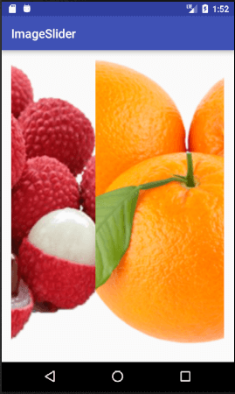

**Android Image Switcher**

Android image switcher provides an animation over images to transition from one image to another. In order to use image switcher, we need to implement **ImageSwitcher** component in .xml file.

The *setFactory()* method of ImageSwitcher provide implementation of *ViewFactory* interface. ViewFactory interface implements its unimplemented method and returns an ImageView.

Example of Image Switcher

Let's implement an image switcher.

Create activity_main.xml and content_main.xml file in layout folder.

Place some images in drawable folder which are to be switch.

activity_main.xml

***File: activity_main.xml***

**<?xml** version="1.0" encoding="utf-8"**?>**

**<android.support.design.widget.CoordinatorLayout** xmlns:android="http://schemas.android.com/apk/res/android"

    xmlns:app="http://schemas.android.com/apk/res-auto"

    xmlns:tools="http://schemas.android.com/tools"

    android:layout_width="match_parent"

    android:layout_height="match_parent"

    android:fitsSystemWindows="true"

    tools:context="com.example.test.imageswitcher.MainActivity"**>**

**<android.support.design.widget.AppBarLayout**

        android:layout_width="match_parent"

        android:layout_height="wrap_content"

        android:theme="@style/AppTheme.AppBarOverlay"**>**

**<android.support.v7.widget.Toolbar**

            android:id="@+id/toolbar"

            android:layout_width="match_parent"

            android:layout_height="?attr/actionBarSize"

            android:background="?attr/colorPrimary"

            app:popupTheme="@style/AppTheme.PopupOverlay" **/>**

**</android.support.design.widget.AppBarLayout>**

**<include** layout="@layout/content_main" **/>**

**</android.support.design.widget.CoordinatorLayout>**

content_main.xml

***File: content_main.xml***

**<?xml** version="1.0" encoding="utf-8"**?>**

**<RelativeLayout** xmlns:android="http://schemas.android.com/apk/res/android"

    xmlns:app="http://schemas.android.com/apk/res-auto"

    xmlns:tools="http://schemas.android.com/tools"

    android:layout_width="match_parent"

    android:layout_height="match_parent"

    android:paddingBottom="@dimen/activity_vertical_margin"

    android:paddingLeft="@dimen/activity_horizontal_margin"

    android:paddingRight="@dimen/activity_horizontal_margin"

    android:paddingTop="@dimen/activity_vertical_margin"

    app:layout_behavior="@string/appbar_scrolling_view_behavior"

    tools:context="com.example.test.imageswitcher.MainActivity"

    tools:showIn="@layout/activity_main"**>**

**<TextView**

        android:layout_width="wrap_content"

        android:layout_height="wrap_content"

        android:text="Image Switcher Example"

        android:id="@+id/textView"

        android:layout_alignParentTop="true"

        android:layout_centerHorizontal="true" **/>**

**<ImageSwitcher**

        android:id="@+id/imageSwitcher"

        android:layout_width="match_parent"

        android:layout_height="250dp"

        android:layout_marginBottom="28dp"

        android:layout_marginTop="40dp" **/>**

**<Button**

        android:layout_width="wrap_content"

        android:layout_height="wrap_content"

        android:text="Next"

        android:id="@+id/button"

        android:layout_marginBottom="47dp"

        android:layout_alignParentBottom="true"

        android:layout_centerHorizontal="true" **/>**

**</RelativeLayout>**

Activity class

***File: MainActivity.java***

**package** com.example.test.imageswitcher;

**import** android.os.Bundle;

**import** android.support.v7.app.AppCompatActivity;

**import** android.support.v7.widget.Toolbar;

**import** android.view.View;

**import** android.widget.Button;

**import** android.widget.ImageSwitcher;

**import** android.widget.ImageView;

**import** android.widget.ViewSwitcher;

**import** android.app.ActionBar;

**import** android.view.animation.Animation;

**import** android.view.animation.AnimationUtils;

**public** **class** MainActivity **extends** AppCompatActivity {

    ImageSwitcher imageSwitcher;

    Button nextButton;

**int** imageSwitcherImages[] =

      {R.drawable.cpp, R.drawable.c_sarp, R.drawable.jsp, R.drawable.mysql, R.drawable.hadoop};

**int** switcherImageLength = imageSwitcherImages.length;

**int** counter = -1;

    @Override

**protected** **void** onCreate(Bundle savedInstanceState) {

**super**.onCreate(savedInstanceState);

        setContentView(R.layout.activity_main);

        Toolbar toolbar = (Toolbar) findViewById(R.id.toolbar);

        setSupportActionBar(toolbar);

        imageSwitcher = (ImageSwitcher) findViewById(R.id.imageSwitcher);

        nextButton = (Button) findViewById(R.id.button);

        imageSwitcher.setFactory(**new** ViewSwitcher.ViewFactory() {

            @Override

**public** View makeView() {

                ImageView switcherImageView = **new** ImageView(getApplicationContext());

                switcherImageView.setLayoutParams(**new** ImageSwitcher.LayoutParams(

                        ActionBar.LayoutParams.FILL_PARENT, ActionBar.LayoutParams.FILL_PARENT

                ));

                switcherImageView.setScaleType(ImageView.ScaleType.FIT_CENTER);

                switcherImageView.setImageResource(R.drawable.hadoop);

                //switcherImageView.setMaxHeight(100);

**return** switcherImageView;

            }

        });

        Animation aniOut = AnimationUtils.loadAnimation(**this**, android.R.anim.slide_out_right);

        Animation aniIn = AnimationUtils.loadAnimation(**this**, android.R.anim.slide_in_left);

       imageSwitcher.setOutAnimation(aniOut);

       imageSwitcher.setInAnimation(aniIn);

        nextButton.setOnClickListener(**new** View.OnClickListener() {

            @Override

**public** **void** onClick(View v) {

                counter++;

**if** (counter == switcherImageLength){

                    counter = 0;

                    imageSwitcher.setImageResource(imageSwitcherImages[counter]);

                }

**else**{

                    imageSwitcher.setImageResource(imageSwitcherImages[counter]);

                }

            }

        });

    }

}

Output:

 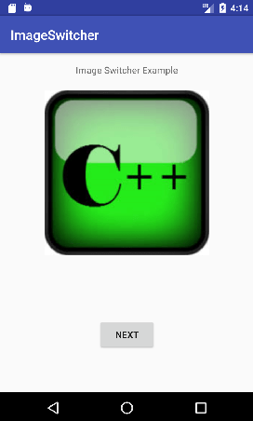

**Android SearchView**

Android **SearchView** provides user interface to search query submitted over search provider. SearchView widget can be implemented over ToolBar/ActionBar or inside a layout.

SearchView is by default collapsible and set to be iconified using *setIconifiedByDefault(true)* method of SearchView class. For making search field visible, SearchView uses setIconifiedByDefault(false) method.

Methods of SearchView

1. **public boolean onQueryTextSubmit(String query):** It searches the query on the submission of content over SearchView editor. It is case dependent.
2. **public boolean onQueryTextChange(String newText):** It searches the query at the time of text change over SearchView editor.

Example of SearchView

Let's see the example of SearchView over layout, searching data in a ListView.

activity_main.xml

Create an activity_main.xml file in layout folder containing ScrollView and ListView.

***File: activity_main.xml***

**<?xml** version="1.0" encoding="utf-8"**?>**

**<RelativeLayout** xmlns:android="http://schemas.android.com/apk/res/android"

    xmlns:tools="http://schemas.android.com/tools"

    android:layout_width="match_parent"

    android:layout_height="match_parent"

    android:paddingBottom="@dimen/activity_vertical_margin"

    android:paddingLeft="@dimen/activity_horizontal_margin"

    android:paddingRight="@dimen/activity_horizontal_margin"

    android:paddingTop="@dimen/activity_vertical_margin"

    tools:context="com.example.test.searchview.MainActivity"**>**

**<ListView**

        android:layout_width="match_parent"

        android:layout_height="match_parent"

        android:id="@+id/lv1"

        android:divider="#ad5"

        android:dividerHeight="2dp"

        android:layout_below="@+id/searchView"**/>**

**<SearchView**

        android:id="@+id/searchView"

        android:layout_width="wrap_content"

        android:layout_height="wrap_content"

        android:queryHint="Search Here"

        android:iconifiedByDefault="false"

        android:layout_alignParentTop="true"

**/>**

**</RelativeLayout>**

Activity class

***File: MainActivity.java***

**package** com.example.test.searchview;

**import** android.support.v7.app.AppCompatActivity;

**import** android.os.Bundle;

**import** android.widget.ArrayAdapter;

**import** android.widget.Filter;

**import** android.widget.ListView;

**import** android.widget.SearchView;

**import** android.widget.Toast;

**import** java.util.ArrayList;

**public** **class** MainActivity **extends** AppCompatActivity {

    SearchView searchView;

    ListView listView;

    ArrayList<String> list;

    ArrayAdapter<String > adapter;

    @Override

**protected** **void** onCreate(Bundle savedInstanceState) {

**super**.onCreate(savedInstanceState);

        setContentView(R.layout.activity_main);

        searchView = (SearchView) findViewById(R.id.searchView);

        listView = (ListView) findViewById(R.id.lv1);

        list = **new** ArrayList<>();

        list.add("Apple");

        list.add("Banana");

        list.add("Pineapple");

        list.add("Orange");

        list.add("Lychee");

        list.add("Gavava");

        list.add("Peech");

        list.add("Melon");

        list.add("Watermelon");

        list.add("Papaya");

        adapter = **new** ArrayAdapter<String>(**this**, android.R.layout.simple_list_item_1,list);

        listView.setAdapter(adapter);

        searchView.setOnQueryTextListener(**new** SearchView.OnQueryTextListener() {

            @Override

**public** **boolean** onQueryTextSubmit(String query) {

**if**(list.contains(query)){

                    adapter.getFilter().filter(query);

                }**else**{

                    Toast.makeText(MainActivity.**this**, "No Match found",Toast.LENGTH_LONG).show();

                }

**return** **false**;

            }

            @Override

**public** **boolean** onQueryTextChange(String newText) {

            //    adapter.getFilter().filter(newText);

**return** **false**;

            }

        });

    }

}

Output:

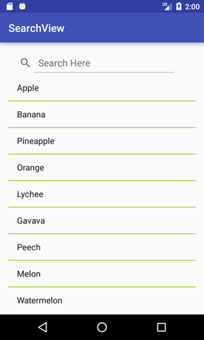 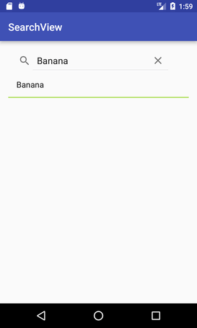

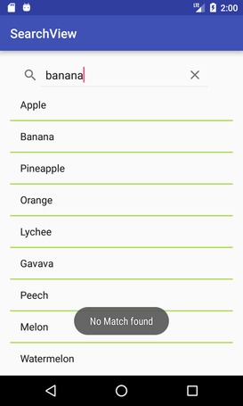

**Android SearchView on ToolBar**

As we have already implemented SearchView widget over activity layout, it can also be implemented over ToolBar/ActionBar. For implementing SearchView over ToolBar, we need to create menu option and place SearchView widget on it.

Example of SearchView on ToolBar (ActionBar)

Let's us see the example of SearchView over ToolBar and searching data in ListView.

Directory Structure of this Example

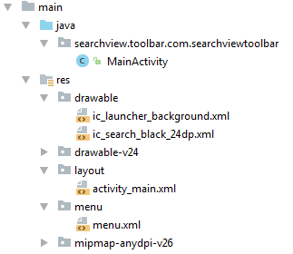

activity_main.xml

Create an activity_main.xml file in layout folder containing ListView.

***File: activity_main.xml***

**<?xml** version="1.0" encoding="utf-8"**?>**

**<android.support.constraint.ConstraintLayout** xmlns:android="http://schemas.android.com/apk/res/android"

    xmlns:app="http://schemas.android.com/apk/res-auto"

    xmlns:tools="http://schemas.android.com/tools"

    android:layout_width="match_parent"

    android:layout_height="match_parent"

    tools:context="searchview.toolbar.com.searchviewtoolbar.MainActivity"**>**

**<ListView**

        android:id="@+id/listView"

        android:layout_width="match_parent"

        android:layout_height="fill_parent"

**/>**

**</android.support.constraint.ConstraintLayout>**

menu.xml

Create a menu.xml file in menu folder and place the following code. This code places the SearchView widget over ToolBar.

***File: menu.xml***

**<?xml** version="1.0" encoding="utf-8"**?>**

**<menu** xmlns:app="http://schemas.android.com/apk/res-auto"

xmlns:android="http://schemas.android.com/apk/res/android"**>**

**<item**

    android:id="@+id/app_bar_search"

    android:icon="@drawable/ic_search_black_24dp"

    android:title="Search"

    app:showAsAction="ifRoom|withText"

    app:actionViewClass="android.widget.SearchView"**/>**

**</menu>**

Activity class

***File: MainActivity.java***

**package** searchview.toolbar.com.searchviewtoolbar;

**import** android.support.v4.view.MenuItemCompat;

**import** android.support.v7.app.AppCompatActivity;

**import** android.os.Bundle;

**import** android.view.Menu;

**import** android.view.MenuInflater;

**import** android.view.MenuItem;

**import** android.widget.ArrayAdapter;

**import** android.widget.ListView;

**import** android.widget.SearchView;

**import** android.widget.Toast;

**import** java.util.ArrayList;

**public** **class** MainActivity **extends** AppCompatActivity {

    ListView listView;

    ArrayList<String> list;

    ArrayAdapter<String > adapter;

    @Override

**protected** **void** onCreate(Bundle savedInstanceState) {

**super**.onCreate(savedInstanceState);

        setContentView(R.layout.activity_main);

        listView = (ListView) findViewById(R.id.listView);

        list = **new** ArrayList<>();

        list.add("Apple");

        list.add("Banana");

        list.add("Pineapple");

        list.add("Orange");

        list.add("Lychee");

        list.add("Gavava");

        list.add("Peech");

        list.add("Melon");

        list.add("Watermelon");

        list.add("Papaya");

        adapter = **new** ArrayAdapter<String>(**this**, android.R.layout.simple_list_item_1,list);

        listView.setAdapter(adapter);

    }

    @Override

**public** **boolean** onCreateOptionsMenu(Menu menu) {

        MenuInflater inflater = getMenuInflater();

        inflater.inflate(R.menu.menu, menu);

        MenuItem searchViewItem = menu.findItem(R.id.app_bar_search);

**final** SearchView searchView = (SearchView) MenuItemCompat.getActionView(searchViewItem);

        searchView.setOnQueryTextListener(**new** SearchView.OnQueryTextListener() {

            @Override

**public** **boolean** onQueryTextSubmit(String query) {

                searchView.clearFocus();

             /*   if(list.contains(query)){

                    adapter.getFilter().filter(query);

                }else{

                    Toast.makeText(MainActivity.this, "No Match found",Toast.LENGTH_LONG).show();

                }*/

**return** **false**;

            }

            @Override

**public** **boolean** onQueryTextChange(String newText) {

                adapter.getFilter().filter(newText);

**return** **false**;

            }

        });

**return** **super**.onCreateOptionsMenu(menu);

    }

}

Output:

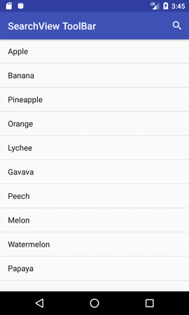 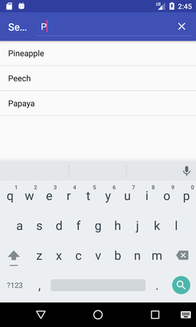 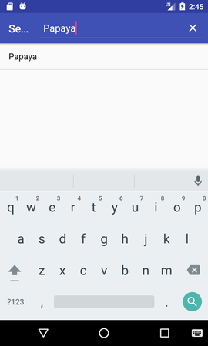

2.6 TAbLayout and FrameLayout

Android TabLayout

**TabLayout** is used to implement horizontal tabs. TabLayout is released by Android after the deprecation of *ActionBar.TabListener (API level 21)*.

TabLayout is introduced in design support library to implement tabs.

Tabs are created using *newTab()* method of TabLayout class. The title and icon of Tabs are set through *setText(int)*and *setIcon(int)*methods of TabListener interface respectively. Tabs of layout are attached over TabLayout using the method addTab(Tab) method.

TabLayout tabLayout = (TabLayout)findViewById(R.id.tabLayout);

tabLayout.addTab(tabLayout.newTab().setText("Tab 1"));

tabLayout.addTab(tabLayout.newTab().setText("Tab 2"));

tabLayout.addTab(tabLayout.newTab().setText("Tab 3"));

We can also add tab item to TabLayout using TabItem of android design widget.

**<android.support.design.widget.TabItem**

             android:text="@string/tab_text"**/>**

Example of TabLayout using ViewPager

Let's create an example of TabLayout using ViewPager and Fragment.

***File: activity.xml***

Create an activity.xml file with TabLayout and ViewPager view components.

**<?xml** version="1.0" encoding="utf-8"**?>**

**<android.support.constraint.ConstraintLayout** xmlns:android="http://schemas.android.com/apk/res/android"

    xmlns:app="http://schemas.android.com/apk/res-auto"

    xmlns:tools="http://schemas.android.com/tools"

    android:layout_width="match_parent"

    android:layout_height="match_parent"

    tools:context="tablayout.example.com.tablayout.MainActivity"**>**

**<android.support.design.widget.TabLayout**

        android:id="@+id/tabLayout"

        android:layout_width="match_parent"

        android:layout_height="wrap_content"

        android:background="#1db995"**>**

**</android.support.design.widget.TabLayout>**

**<android.support.v4.view.ViewPager**

        android:id="@+id/viewPager"

        android:layout_width="355dp"

        android:layout_height="455dp"

        app:layout_constraintTop_toBottomOf="@+id/tabLayout"

        tools:layout_editor_absoluteX="8dp" **/>**

**</android.support.constraint.ConstraintLayout>**

***File: build.gradle***

Now gave the dependency library of TabLayout in build.gradle file.

implementation 'com.android.support:design:26.1.0'

***File: MainActivity.java***

In this file, we implement two additional listener *addOnPageChangeListener(listener)* of ViewPager which makes slides the different fragments of tabs and *addOnTabSelectedListener(listener)* of TabLayout which select the current tab on tab selection.

**package** tablayout.example.com.tablayout;

**import** android.support.design.widget.TabLayout;

**import** android.support.v4.view.ViewPager;

**import** android.support.v7.app.AppCompatActivity;

**import** android.os.Bundle;

**public** **class** MainActivity **extends** AppCompatActivity {

    TabLayout tabLayout;

    ViewPager viewPager;

    @Override

**protected** **void** onCreate(Bundle savedInstanceState) {

**super**.onCreate(savedInstanceState);

        setContentView(R.layout.activity_main);

        tabLayout=(TabLayout)findViewById(R.id.tabLayout);

        viewPager=(ViewPager)findViewById(R.id.viewPager);

        tabLayout.addTab(tabLayout.newTab().setText("Home"));

        tabLayout.addTab(tabLayout.newTab().setText("Sport"));

        tabLayout.addTab(tabLayout.newTab().setText("Movie"));

        tabLayout.setTabGravity(TabLayout.GRAVITY_FILL);

**final** MyAdapter adapter = **new** MyAdapter(**this**,getSupportFragmentManager(), tabLayout.getTabCount());

        viewPager.setAdapter(adapter);

        viewPager.addOnPageChangeListener(**new** TabLayout.TabLayoutOnPageChangeListener(tabLayout));

         tabLayout.addOnTabSelectedListener(**new** TabLayout.OnTabSelectedListener() {

            @Override

**public** **void** onTabSelected(TabLayout.Tab tab) {

                viewPager.setCurrentItem(tab.getPosition());

            }

            @Override

**public** **void** onTabUnselected(TabLayout.Tab tab) {

            }

            @Override

**public** **void** onTabReselected(TabLayout.Tab tab) {

            }

        });

    }

}

***File: MyAdapter.java***

**package** tablayout.example.com.tablayout;

**import** android.content.Context;

**import** android.support.v4.app.Fragment;

**import** android.support.v4.app.FragmentPagerAdapter;

**import** android.support.v4.app.FragmentManager;

**public** **class** MyAdapter **extends** FragmentPagerAdapter {

**private** Context myContext;

**int** totalTabs;

**public** MyAdapter(Context context, FragmentManager fm, **int** totalTabs) {

**super**(fm);

        myContext = context;

**this**.totalTabs = totalTabs;

    }

    // this is for fragment tabs

    @Override

**public** Fragment getItem(**int** position) {

**switch** (position) {

**case** 0:

                HomeFragment homeFragment = **new** HomeFragment();

**return** homeFragment;

**case** 1:

                SportFragment sportFragment = **new** SportFragment();

**return** sportFragment;

**case** 2:

                MovieFragment movieFragment = **new** MovieFragment();

**return** movieFragment;

**default**:

**return** **null**;

        }

    }

// this counts total number of tabs

    @Override

**public** **int** getCount() {

**return** totalTabs;

    }

}

Now create different fragment files for all different tabs.

***File: HomeFragment.java***

**package** tablayout.example.com.tablayout;

**import** android.os.Bundle;

**import** android.support.v4.app.Fragment;

**import** android.view.LayoutInflater;

**import** android.view.View;

**import** android.view.ViewGroup;

**public** **class** HomeFragment **extends** Fragment {

**public** HomeFragment() {

        // Required empty public constructor

    }

    @Override

**public** View onCreateView(LayoutInflater inflater, ViewGroup container,

                             Bundle savedInstanceState) {

        // Inflate the layout for this fragment

**return** inflater.inflate(R.layout.fragment_home, container, **false**);

    }

}

***File: fragment_home.xml***

**<FrameLayout** xmlns:android="http://schemas.android.com/apk/res/android"

    xmlns:tools="http://schemas.android.com/tools"

    android:layout_width="match_parent"

    android:layout_height="match_parent"

    tools:context="tablayout.example.com.tablayout.HomeFragment"**>**

    <!-- TODO: Update blank fragment layout -->

**<TextView**

        android:layout_width="match_parent"

        android:layout_height="match_parent"

        android:gravity="center"

        android:text="@string/home_fragment" **/>**

**</FrameLayout>**

***File: SportFragment.java***

**package** tablayout.example.com.tablayout;

**import** android.os.Bundle;

**import** android.support.v4.app.Fragment;

**import** android.view.LayoutInflater;

**import** android.view.View;

**import** android.view.ViewGroup;

**public** **class** SportFragment **extends** Fragment {

**public** SportFragment() {

        // Required empty public constructor

    }

    @Override

**public** View onCreateView(LayoutInflater inflater, ViewGroup container,

                             Bundle savedInstanceState) {

        // Inflate the layout for this fragment

**return** inflater.inflate(R.layout.fragment_sport, container, **false**);

    }

}

**File: fragment_sport.xml**

<FrameLayout xmlns:android="http://schemas.android.com/apk/res/android"

    xmlns:tools="http://schemas.android.com/tools"

    android:layout_width="match_parent"

    android:layout_height="match_parent"

    tools:context="tablayout.example.com.tablayout.SportFragment">

    <!-- TODO: Update blank fragment layout -->

    <TextView

        android:layout_width="match_parent"

        android:layout_height="match_parent"

        android:gravity="center"

        android:text="@string/sport_fragment" />

</FrameLayout>

***File: MovieFragment.java***

**package** tablayout.example.com.tablayout;

**import** android.os.Bundle;

**import** android.support.v4.app.Fragment;

**import** android.view.LayoutInflater;

**import** android.view.View;

**import** android.view.ViewGroup;

**public** **class** MovieFragment **extends** Fragment {

**public** MovieFragment() {

        // Required empty public constructor

    }

    @Override

**public** View onCreateView(LayoutInflater inflater, ViewGroup container,

                             Bundle savedInstanceState) {

        // Inflate the layout for this fragment

**return** inflater.inflate(R.layout.fragment_movie, container, **false**);

    }

}

***File: fragment_movie.xml***

**<FrameLayout** xmlns:android="http://schemas.android.com/apk/res/android"

    xmlns:tools="http://schemas.android.com/tools"

    android:layout_width="match_parent"

    android:layout_height="match_parent"

    tools:context="tablayout.example.com.tablayout.MovieFragment"**>**

    <!-- TODO: Update blank fragment layout -->

**<TextView**

        android:layout_width="match_parent"

        android:layout_height="match_parent"

        android:gravity="center"

        android:text="@string/movie_fragment" **/>**

**</FrameLayout>**

**File: strings.xml**

**<resources>**

**<string** name="app_name"**>**TabLayout**</string>**

    <!-- TODO: Remove or change this placeholder text -->

**<string** name="home_fragment"**>**Home Fragment**</string>**

**<string** name="sport_fragment"**>**Sport Fragment**</string>**

**<string** name="movie_fragment"**>**Movie Fragment**</string>**

**</resources>**

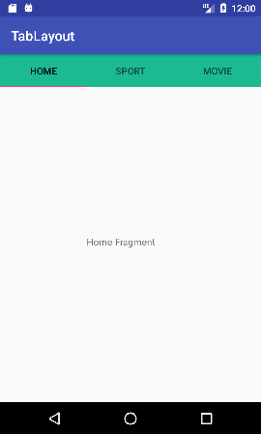 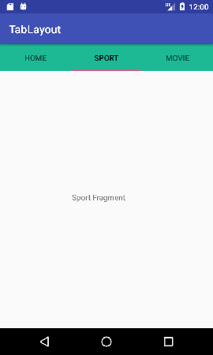

**Android TabLayout with FrameLayout**

In the previous page, we created a sliding tabs using TabLayout and ViewPager. Here, we are going to create non sliding tabs using *TabLayout* and *FrameLayout*.

Items of TabLayout are implemented by adding *TabItem* of android support design widget.

Example of TabLayout using FrameLayout

Let's create an example of TabLayout using FrameLayout and Fragment.

***File: activity.xml***

Create an activity.xml file with TabLayout and FrameLayout view components.

**<?xml** version="1.0" encoding="utf-8"**?>**

**<android.support.constraint.ConstraintLayout** xmlns:android="http://schemas.android.com/apk/res/android"

    xmlns:app="http://schemas.android.com/apk/res-auto"

    xmlns:tools="http://schemas.android.com/tools"

    android:layout_width="match_parent"

    android:layout_height="match_parent"

    tools:context="tablayout.example.com.tablayoutwithframelayout.MainActivity"**>**

**<android.support.design.widget.TabLayout**

        android:id="@+id/tabLayout"

        android:layout_width="match_parent"

        android:layout_height="wrap_content"

        android:background="#7367"**>**

**<android.support.design.widget.TabItem**

            android:layout_width="wrap_content"

            android:layout_height="wrap_content"

            android:text="Home" **/>**

**<android.support.design.widget.TabItem**

            android:layout_width="wrap_content"

            android:layout_height="wrap_content"

            android:text="Java" **/>**

**<android.support.design.widget.TabItem**

            android:layout_width="wrap_content"

            android:layout_height="wrap_content"

            android:text="Android" **/>**

**<android.support.design.widget.TabItem**

            android:layout_width="wrap_content"

            android:layout_height="wrap_content"

            android:text="Php" **/>**

**</android.support.design.widget.TabLayout>**

**<FrameLayout**

        android:id="@+id/frameLayout"

        android:layout_width="match_parent"

        android:layout_height="455dp"

        app:layout_constraintEnd_toEndOf="parent"

        app:layout_constraintStart_toStartOf="parent"

        app:layout_constraintTop_toBottomOf="@+id/tabLayout"**>**

**</FrameLayout>**

**</android.support.constraint.ConstraintLayout>**

***File: build.gradle***

Now gave the dependency library of TabLayout in build.gradle file.

implementation 'com.android.support:design:26.1.0'

***File: MainActivity.java***

package tablayout.example.com.tablayoutwithframelayout;

import android.support.design.widget.TabLayout;

import android.support.v4.app.Fragment;

import android.support.v4.app.FragmentManager;

import android.support.v4.app.FragmentTransaction;

import android.support.v7.app.AppCompatActivity;

import android.os.Bundle;

import android.widget.FrameLayout;

public class MainActivity extends AppCompatActivity {

    TabLayout tabLayout;

    FrameLayout frameLayout;

    Fragment fragment = null;

    FragmentManager fragmentManager;

    FragmentTransaction fragmentTransaction;

    @Override

    protected void onCreate(Bundle savedInstanceState) {

        super.onCreate(savedInstanceState);

        setContentView(R.layout.activity_main);

        tabLayout=(TabLayout)findViewById(R.id.tabLayout);

        frameLayout=(FrameLayout)findViewById(R.id.frameLayout);

        fragment = new HomeFragment();

        fragmentManager = getSupportFragmentManager();

        fragmentTransaction = fragmentManager.beginTransaction();

        fragmentTransaction.replace(R.id.frameLayout, fragment);

        fragmentTransaction.setTransition(FragmentTransaction.TRANSIT_FRAGMENT_OPEN);

        fragmentTransaction.commit();

        tabLayout.addOnTabSelectedListener(new TabLayout.OnTabSelectedListener() {

            @Override

            public void onTabSelected(TabLayout.Tab tab) {

               // Fragment fragment = null;

                switch (tab.getPosition()) {

                    case 0:

                        fragment = new HomeFragment();

                        break;

                    case 1:

                        fragment = new JavaFragment();

                        break;

                    case 2:

                        fragment = new AndroidFragment();

                        break;

                    case 3:

                        fragment = new PhpFragment();

                        break;

                }

                FragmentManager fm = getSupportFragmentManager();

                FragmentTransaction ft = fm.beginTransaction();

                ft.replace(R.id.frameLayout, fragment);

                ft.setTransition(FragmentTransaction.TRANSIT_FRAGMENT_OPEN);

                ft.commit();

            }

            @Override

            public void onTabUnselected(TabLayout.Tab tab) {

            }

            @Override

            public void onTabReselected(TabLayout.Tab tab) {

            }

        });

    }

}

Now create different fragment files for all different tabs.

***File: HomeFragment.java***

**package** tablayout.example.com.tablayoutwithframelayout;

**import** android.os.Bundle;

**import** android.support.v4.app.Fragment;

**import** android.view.LayoutInflater;

**import** android.view.View;

**import** android.view.ViewGroup;

**public** **class** HomeFragment **extends** Fragment {

**public** HomeFragment() {

        // Required empty public constructor

    }

    @Override

**public** View onCreateView(LayoutInflater inflater, ViewGroup container,

                             Bundle savedInstanceState) {

        // Inflate the layout for this fragment

**return** inflater.inflate(R.layout.fragment_home, container, **false**);

    }

}

***File: fragment_home.xml***

**<FrameLayout** xmlns:android="http://schemas.android.com/apk/res/android"

    xmlns:tools="http://schemas.android.com/tools"

    android:layout_width="match_parent"

    android:layout_height="match_parent"

    tools:context="tablayout.example.com.tablayoutwithframelayout.HomeFragment"**>**

    <!-- TODO: Update blank fragment layout -->

**<TextView**

        android:layout_width="match_parent"

        android:layout_height="match_parent"

        android:gravity="center"

        android:text="@string/home_fragment" **/>**

**</FrameLayout>**

***File: JavaFragment.java***

**package** tablayout.example.com.tablayoutwithframelayout;

**import** android.os.Bundle;

**import** android.support.v4.app.Fragment;

**import** android.view.LayoutInflater;

**import** android.view.View;

**import** android.view.ViewGroup;

**public** **class** JavaFragment **extends** Fragment {

**public** JavaFragment() {

        // Required empty public constructor

    }

    @Override

**public** View onCreateView(LayoutInflater inflater, ViewGroup container,

                             Bundle savedInstanceState) {

        // Inflate the layout for this fragment

**return** inflater.inflate(R.layout.fragment_java, container, **false**);

    }

}

***File: fragment_java.xml***

**<FrameLayout** xmlns:android="http://schemas.android.com/apk/res/android"

    xmlns:tools="http://schemas.android.com/tools"

    android:layout_width="match_parent"

    android:layout_height="match_parent"

    tools:context="tablayout.example.com.tablayoutwithframelayout.JavaFragment"**>**

    <!-- TODO: Update blank fragment layout -->

**<TextView**

        android:layout_width="match_parent"

        android:layout_height="match_parent"

        android:gravity="center"

        android:text="@string/java_fragment" **/>**

**</FrameLayout>**

***File: AndroidFragment.java***

**package** tablayout.example.com.tablayoutwithframelayout;

**import** android.os.Bundle;

**import** android.support.v4.app.Fragment;

**import** android.view.LayoutInflater;

**import** android.view.View;

**import** android.view.ViewGroup;

**public** **class** AndroidFragment **extends** Fragment {

**public** AndroidFragment() {

        // Required empty public constructor

    }

    @Override

**public** View onCreateView(LayoutInflater inflater, ViewGroup container,

                             Bundle savedInstanceState) {

        // Inflate the layout for this fragment

**return** inflater.inflate(R.layout.fragment_android, container, **false**);

    }

}

***File: fragment_android.xml***

**<FrameLayout** xmlns:android="http://schemas.android.com/apk/res/android"

    xmlns:tools="http://schemas.android.com/tools"

    android:layout_width="match_parent"

    android:layout_height="match_parent"

    tools:context="tablayout.example.com.tablayoutwithframelayout.AndroidFragment"**>**

    <!-- TODO: Update blank fragment layout -->

**<TextView**

        android:layout_width="match_parent"

        android:layout_height="match_parent"

        android:gravity="center"

        android:text="@string/android_fragment" **/>**

**</FrameLayout>**

***File: PhpFragment.java***

**package** tablayout.example.com.tablayoutwithframelayout;

**import** android.os.Bundle;

**import** android.support.v4.app.Fragment;

**import** android.view.LayoutInflater;

**import** android.view.View;

**import** android.view.ViewGroup;

**public** **class** PhpFragment **extends** Fragment {

**public** PhpFragment() {

        // Required empty public constructor

    }

    @Override

**public** View onCreateView(LayoutInflater inflater, ViewGroup container,

                             Bundle savedInstanceState) {

        // Inflate the layout for this fragment

**return** inflater.inflate(R.layout.fragment_php, container, **false**);

    }

}

***File: fragment_php.xml***

**<FrameLayout** xmlns:android="http://schemas.android.com/apk/res/android"

    xmlns:tools="http://schemas.android.com/tools"

    android:layout_width="match_parent"

    android:layout_height="match_parent"

    tools:context="tablayout.example.com.tablayoutwithframelayout.PhpFragment"**>**

    <!-- TODO: Update blank fragment layout -->

**<TextView**

        android:layout_width="match_parent"

        android:layout_height="match_parent"

        android:gravity="center"

        android:text="@string/php_fragment" **/>**

**</FrameLayout>**

***File: strings.xml***

**<resources>**

**<string** name="app_name"**>**TabLayout with FrameLayout**</string>**

    <!-- TODO: Remove or change this placeholder text -->

**<string** name="home_fragment"**>**Home fragment**</string>**

**<string** name="java_fragment"**>**Java fragment**</string>**

**<string** name="android_fragment"**>**Android fragment**</string>**

**<string** name="php_fragment"**>**Php fragment**</string>**

**</resources>**

Output:

